Data Handling and Visualization (DSA06)
Name: Prasanna M Reg. No: 1925260244
Set 25: Website Traffic Analysis
Question 1. In Tableau, create a line chart to visualize the trend in page views over time. Label the axes and title the chart.
Procedure (Tableau):
1. Open Tableau, click Connect, choose Text file / Microsoft Excel, select "Website_Traffic.csv" and open Sheet 1.
2. Drag Date to Columns and change it to Day (continuous, green pill); drag Page Views to Rows (SUM).
3. Mark type = Line; add circles and drag Page Views to Label.
4. Edit the axis titles to "Date" and "Page Views", and double-click the sheet title to enter "Trend in Daily Page Views".
5. Save the sheet (File > Save As, .twbx).

Output:
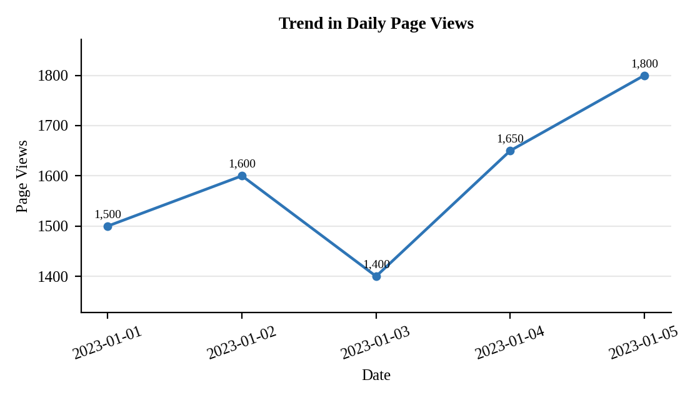
Interpretation:
Page views climb from 1500 on 1 January to 1800 on 5 January, a rise of 20%. The only dip is on 3 January (1400), after which traffic recovers strongly to 1650 and then 1800.

Question 2. In R, generate a bar chart to show the top N days with the highest click-through rates. Label the chart elements.
Program (R):
library(ggplot2)
web <- data.frame(Date = as.Date(c("2023-01-01","2023-01-02","2023-01-03","2023-01-04","2023-01-05")),
Page_Views = c(1500,1600,1400,1650,1800),
CTR = c(2.3,2.7,2.0,2.4,2.6))
N <- 3
top_n <- head(web[order(-web$CTR), ], N)
ggplot(top_n, aes(x = reorder(format(Date), -CTR), y = CTR)) +
geom_col(fill = "steelblue", colour = "black", width = 0.6) +
geom_text(aes(label = paste0(CTR, "%")), vjust = -0.3) +
labs(title = paste("Top", N, "Days by Click-through Rate"),
x = "Date", y = "Click-through Rate (%)") +
theme_minimal()
Output:
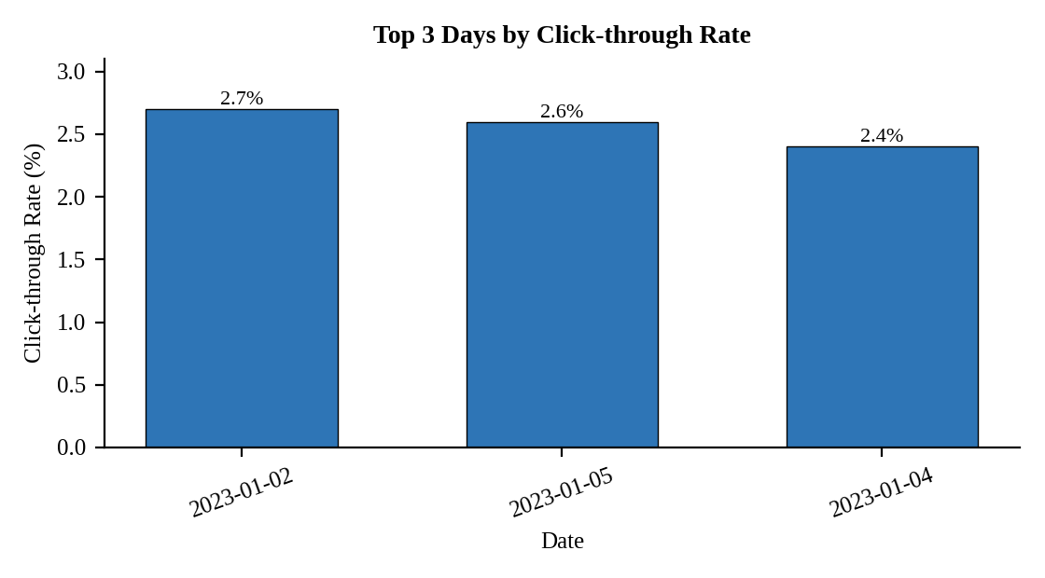
Interpretation:
For N = 3 the best days are 2 January (2.7%), 5 January (2.6%) and 4 January (2.4%). The best click-through day (2 January) did not have the most page views, so high traffic does not always mean a higher click-through rate.

Question 3. In R, build a stacked area chart to display the distribution of user interactions (likes, shares, comments) on the website.
Assumed data: Interaction counts are not given, so sample daily counts of likes, shares and comments are used.
Program (R):
library(tidyr)
act <- data.frame(Date = web$Date,
Likes = c(120,150,110,160,180),
Shares = c(40,55,35,60,70),
Comments = c(25,30,20,35,45))
long <- pivot_longer(act, cols = c(Likes, Shares, Comments),
names_to = "Interaction", values_to = "Count")
ggplot(long, aes(x = Date, y = Count, fill = Interaction)) +
geom_area(position = "stack", colour = "white") +
labs(title = "User Interactions on the Website", x = "Date", y = "Number of Interactions") +
theme_minimal()
Output:
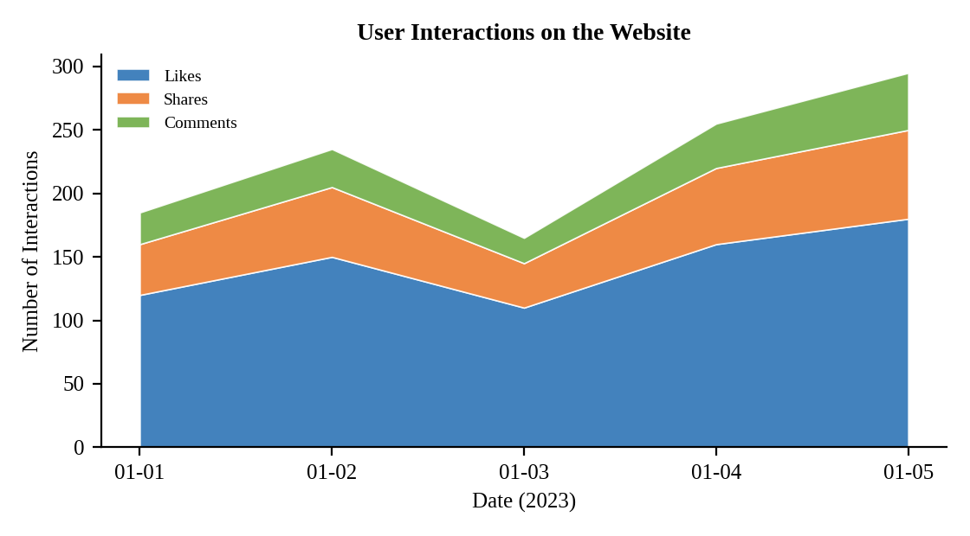
Interpretation:
Total interactions rise from 185 on 1 January to 295 on 5 January, with a dip to 165 on 3 January that matches the page-view dip. Likes form the largest layer (63% of all interactions), followed by shares and then comments.

Question 4. In Tableau, create a dashboard with an interactive map showing traffic sources and a bar chart displaying page views by source.
Assumed data: Traffic sources are not given, so page views are split by country: India 3000, USA 2000, UK 1100, Germany 900 and Australia 950 (total 7950).
Procedure (Tableau):
1. Open Tableau, click Connect, choose Text file / Microsoft Excel, select "Website_Traffic_Sources.csv" and open Sheet 1.
2. Sheet 1 (Map): double-click Country so that Tableau creates Latitude and Longitude; drag SUM(Page Views) to Size and Color; mark type = Map (or Filled Map); add labels.
3. Sheet 2 (Bar): Columns = SUM(Page Views); Rows = Country; sort descending; add labels.
4. Click New Dashboard, name it "Traffic Sources Dashboard", set Size to Automatic and drag the sheets onto the canvas.
5. Place the map on the left and the bar chart on the right; on the map choose "Use as Filter" so that selecting a country filters the bar chart, and add a tooltip showing Country and Page Views.
6. Add a title to every sheet, adjust labels and colours, and save the workbook (File > Save As, .twbx).

Output:
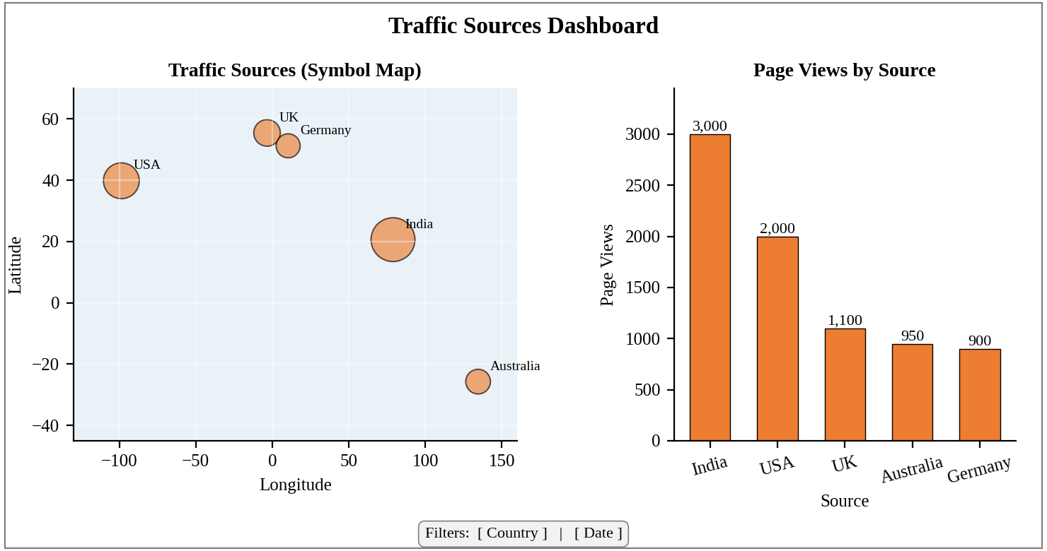
Dashboard layout (preview; Tableau draws the actual base map).
Interpretation:
India is the largest source with 3000 of the 7950 page views (about 38%), followed by the USA (25%). Selecting a country on the map highlights its bar, so the team can see where the audience is concentrated and plan regional campaigns.

